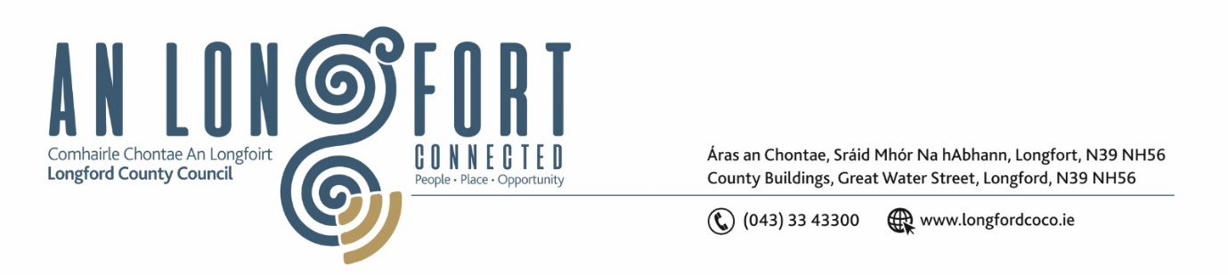

***LONGFORD MUNICIPAL DISTRICT***

***Please note meeting will be held in the Council Chamber, Aras an Chontae and via Microsoft Teams***

**17 November 2022.**

**To: Each Member of Longford Municipal District.**

**Dear Member,**

You are requested to attend the Meeting of Longford Municipal District to be held in **the Council Chamber, Aras an Chontae** and **via Microsoft Teams** on **Wednesday 23 November 2022 at 3.30pm** to transact business, as set out on the agenda hereunder.

**Yours sincerely**,

Ann Marie Mc Keon

_______________

**Ann Marie Mc Keon**

**Meetings Administrator.**

**AGENDA**

Prayer before meeting.

**1.** Confirmation of Minutes:

1. Longford Municipal District Committee Meeting held on Wednesday 26 October 2022 – to follow.
2. Longford Municipal District Meeting held on Wednesday 26 October 2022 – to follow.

**2.** Matters arising from Minutes.

**3.** Declaration of Interest by Members.

**4.** Management Report – to follow.

**5.** Consideration of Part VIII No. 101 - Shared Pedestrian/Cyclist Bridge over River Camlin with connecting pedestrian and cycleway provision either side of existing service road at Abbeycartron/Templemichael, Longford Town, Longford. Report in accordance with Section 179 of the Planning and Development Act 2000 (as amended) and Part 8 of the Planning & Development Regulations 2001 (as amended) – enclosed.

**6.** Consideration of Part VIII No 97 – Construction of Storage Room, changes to layout of first floor and works to the changing rooms to the Leisure Centre, Albert Reynolds Peace Park, Longford. Report in accordance with Section 179 of the Planning and Development Act 2000 (as amended) and Part 8 of the Planning & Development Regulations 2001 (as amended) – enclosed.

**7.** Considerationof Part VIII No. 100 – Proposed Skatepark with Royal Canal Greenway connection at the Old Greyhound Track, Townparks, Longford. Report in accordance with Section 179 of the Planning and Development Act 2000 (as amended) and Part 8 of the Planning & Development Regulations 2001 (as amended) – enclosed.

**8.** **Notices of Motions, submitted by Councillors, as listed hereunder –**

**Councillor Peggy Nolan**

I am requesting Longford County Council to carry out an extensive review of all storm drains in the Longford Town area. The situation on Convent Road needs immediate attention as the effect of climate change is impacting on the height of the surface water and this in turn is impacting on pedestrians.